Sean Parrell

October 11th, 2024

CIS4930

Rest API Design Assignment

For Part 1 of this assignment, attached below is a screenshot of the Sequence Diagram I made with the help of the website mentioned in the rubric, Lucidchart:

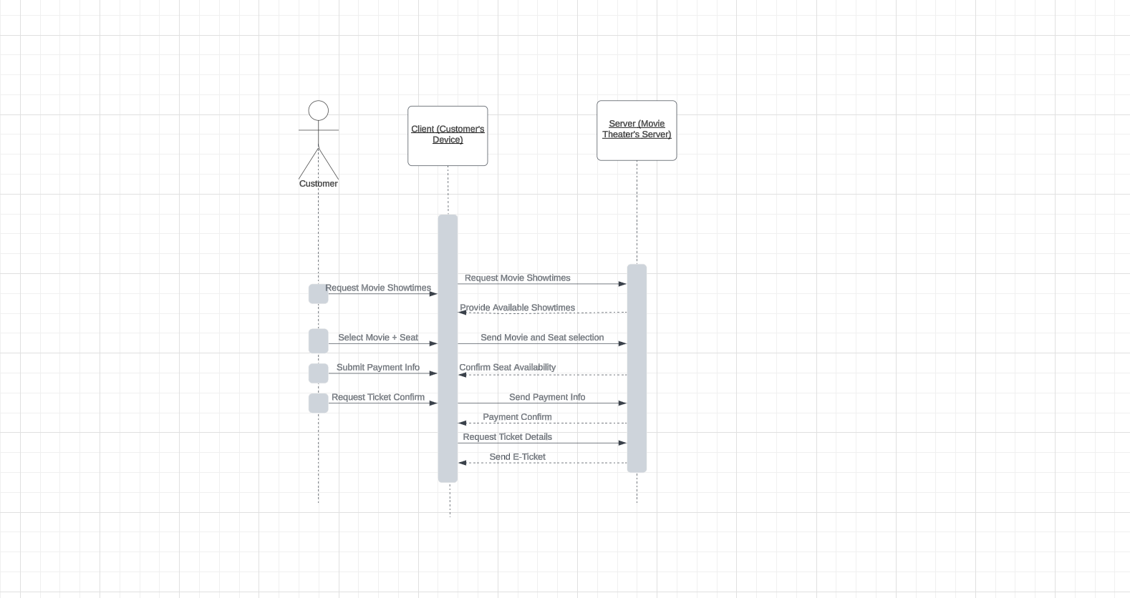

For Part 2 of the assignment, attached below is a link to the Github Repository for the OpenAPI part I made:

<https://github.com/sparrell1/Movie-Ticket-Payment-API/blob/main/movie_ticket_payment_api.yaml>